Project title: NextGen Attendance: A Deep Learning-Based Web Application for Automated Attendance Management using Facial Recognition
Group ID: 03
Project Members Name:-

SN | PRN Number | Name of students | Signature
1 | 240205241023 | Kaushal Kumar Ray

Problem Statement

Manual attendance systems are slow and can be manipulated. Students can give proxy attendance, and maintaining records is difficult.
The problem is to design a system that can automatically mark attendance using face recognition in a secure and efficient way.

Objectives
- To develop an automated attendance system using face recognition.
- To reduce manual effort and proxy attendance.
- To improve accuracy using deep learning.
- To store attendance data securely.
- To create a user-friendly web interface .

Acknowledgement:
I would like to express my sincere gratitude to my project guide for their valuable guidance, support, and encouragement throughout the development of this project. Their insights and suggestions helped me improve the quality of my work.
I am also thankful to the faculty members of the School of Computer Science & Engineering, Sandip University, for providing the necessary resources and knowledge required to complete this project successfully.
I would like to thank my friends and classmates for their support and cooperation during the project.
Lastly, I am grateful to my family and mentors for their constant encouragement and motivation.
Abstract:
Traditional attendance systems are inefficient, time-consuming, and prone to manipulation such as proxy attendance. This project presents an intelligent attendance system based on deep learning and facial recognition techniques. The system captures facial images, extracts high-dimensional embeddings using models such as ArcFace and DeepFace, and compares them with stored data for identity verification.
A web-based interface built using Flask allows real-time attendance tracking and visualization. The system is integrated with a PostgreSQL database for secure data storage and Cloudinary for image handling. Experimental results show improved accuracy, reduced manual effort, and enhanced security compared to traditional methods. The system also includes attendance percentage calculation and automated leave management.

Keywords: Face Recognition, Deep Learning, Attendance System, ArcFace, DeepFace, Computer Vision.

Introduction:
Attendance monitoring plays a critical role in educational institutions and organizations. Traditional methods such as manual roll calls and RFID-based systems are inefficient and vulnerable to misuse.
With advancements in deep learning, facial recognition has emerged as a reliable biometric solution. Deep Convolutional Neural Networks (DCNNs) can extract unique facial features and generate embeddings that enable accurate identity matching.
This project proposes a web-based automated attendance system using facial recognition. The system leverages deep learning models, real-time video processing, and cloud integration to provide a scalable and secure solution.

Literature Review:
Traditional systems relied on Haar Cascade and LBPH algorithms, which suffer from low accuracy under varying environmental conditions. Modern approaches use deep learning-based models such as FaceNet and DeepFace for feature extraction and recognition.

Recent research shows that deep learning models such as FaceNet and DeepFace provide better accuracy and performance. These models convert faces into numerical embeddings and compare them using similarity measures . (Reference GJETA)

ArcFace-based models further improve accuracy by increasing the difference between different faces and reducing variation within the same face. (Reference ArcFace)

Tools and Technologies:
- Python (Flask) for backend
- HTML, CSS, JavaScript for frontend
- PostgreSQL (Neon) for database
- OpenCV for image processing
- DeepFace (ArcFace/FaceNet) for face recognition
- Image storage database (Cloudinary)

Methodology:
The system operates in two main phases:

🔹 1. Registration Phase
- Students register using name and ID
- Multiple facial images are captured using a camera
- Images are preprocessed (face detection, resizing)
- Facial embeddings are generated using DeepFace (ArcFace model)
- Embeddings and student data are stored in the database
This is implemented using:
- capture_face() → captures dataset
- generate_embeddings() → creates embeddings

🔹 2. Training Phase
- Collected images are processed
- Embeddings are generated and saved (embeddings.pkl)
- Model becomes ready for recognition

Implemented in:
- train_model()
3. Attendance Phase
- Live camera input is captured
- Faces are detected using OpenCV
- Embeddings are generated in real-time
- Compared with stored embeddings using distance metric
If match found:
- Attendance is marked in database
This is handled by:
- process_attendance()
4. Attendance Logic
- Attendance stored with date & time
- Prevents duplicate entries
- Retrieves attendance history
5. Leave Management System
- Attendance % is calculated
- If ≥ 80% → auto-approved
- Else → pending approval
Implemented in:
- Leave logic - leave_routes.py

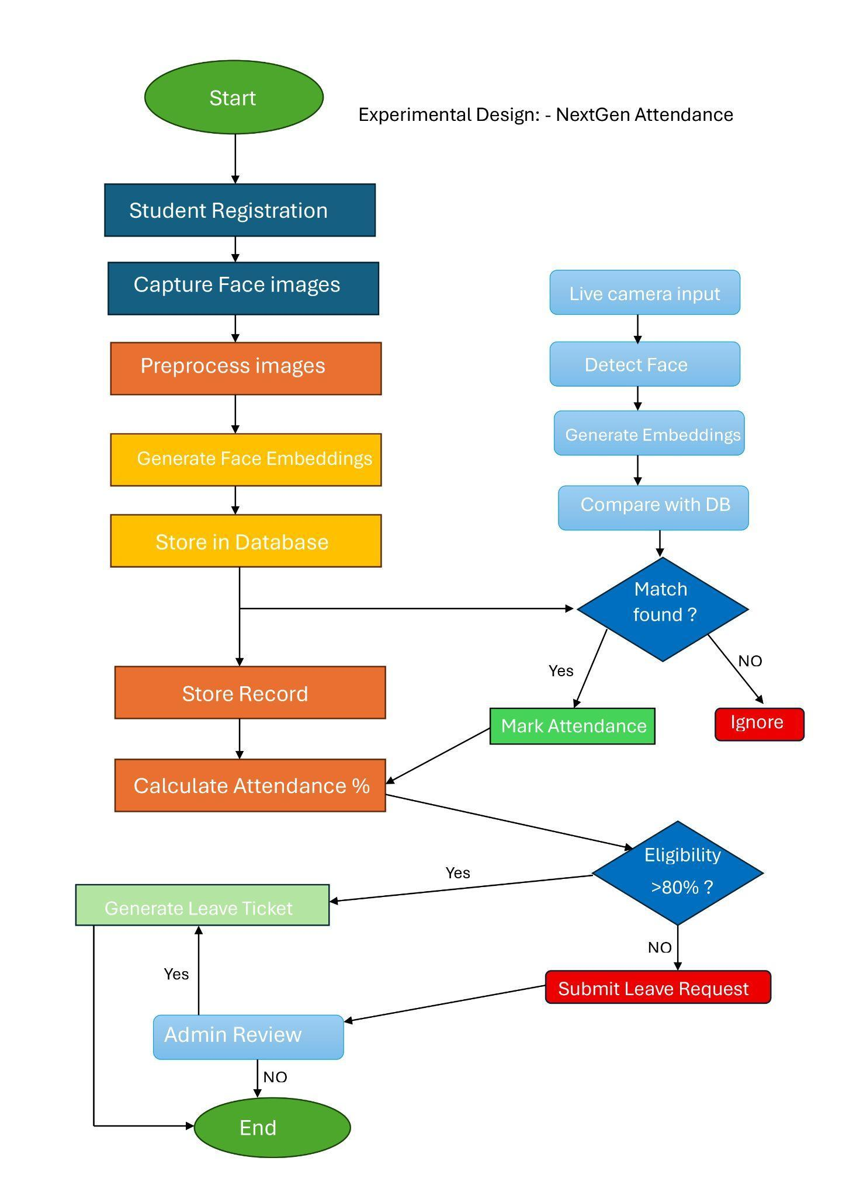

Experimental Design:

System Architecture:

The system follows a modular architecture:

Flask backend handles API routes

Blueprints separate modules (auth, student, attendance, leave)

Frontend communicates via REST APIs

From your app:

Blueprint structure

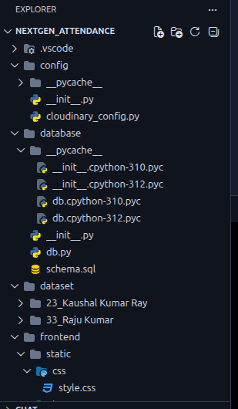
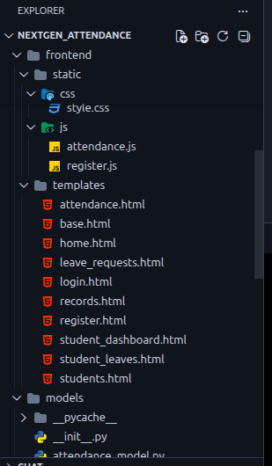
Code work and actual system:

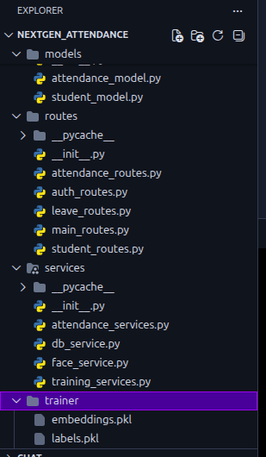
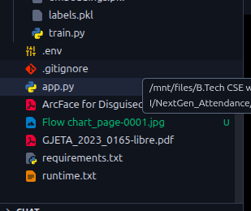

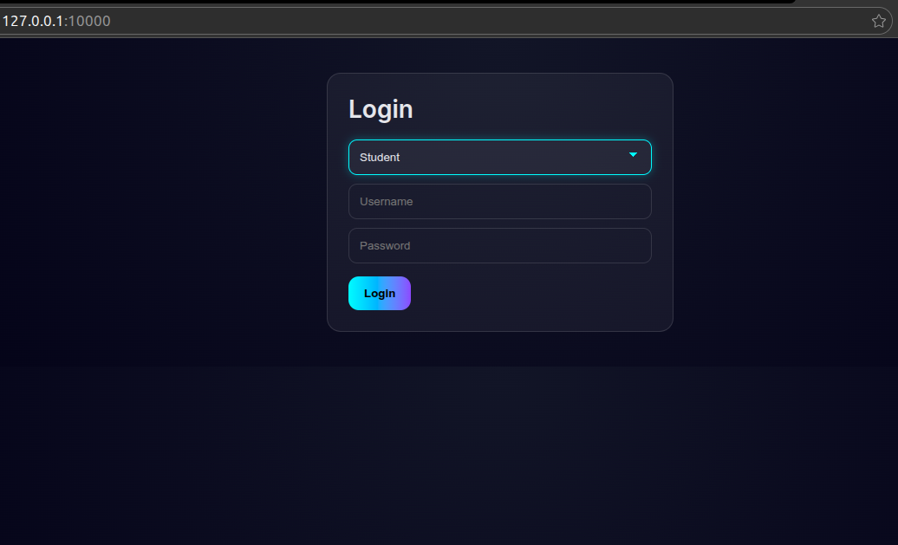



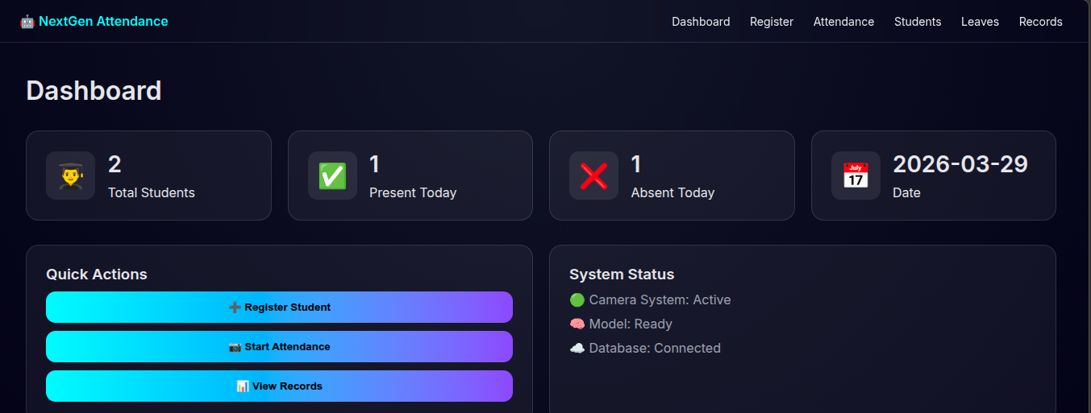

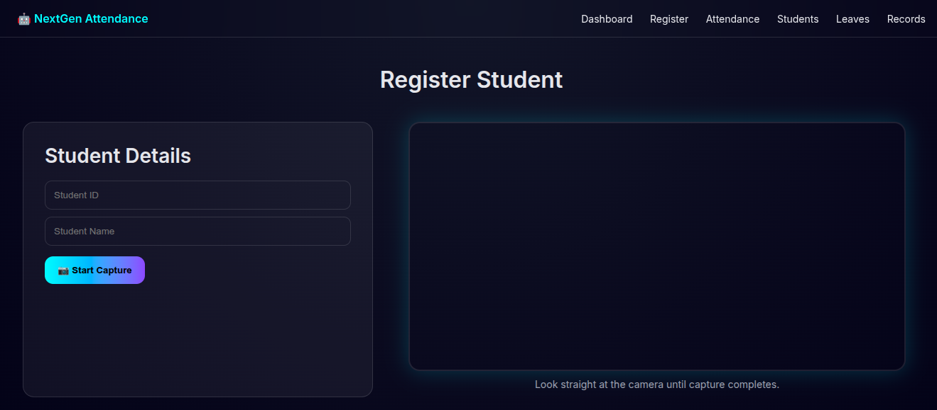

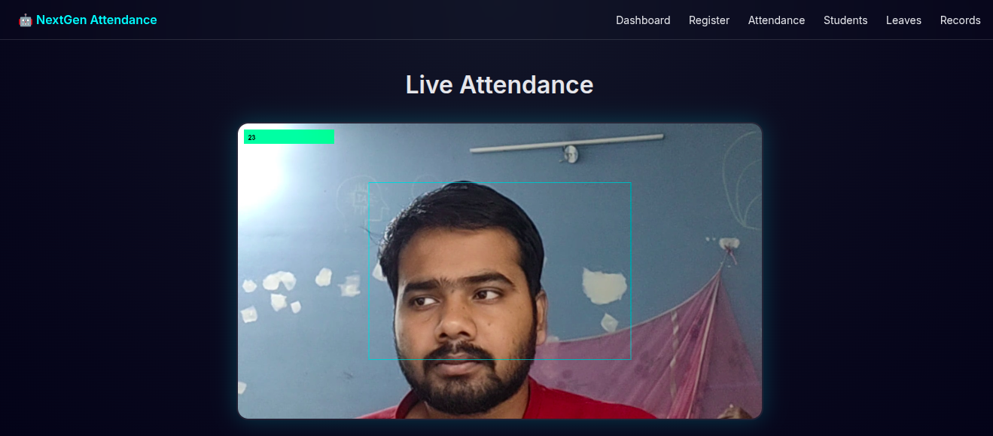

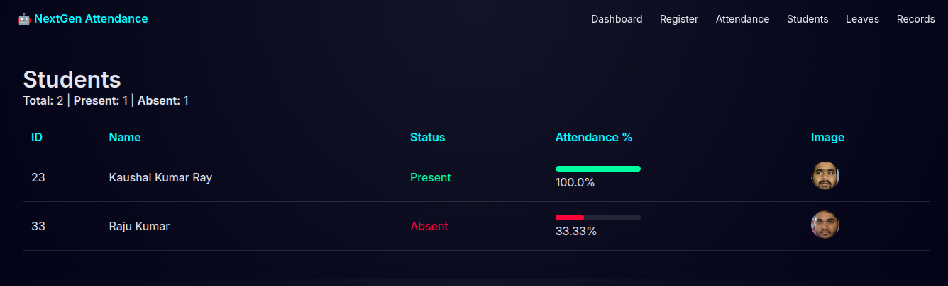

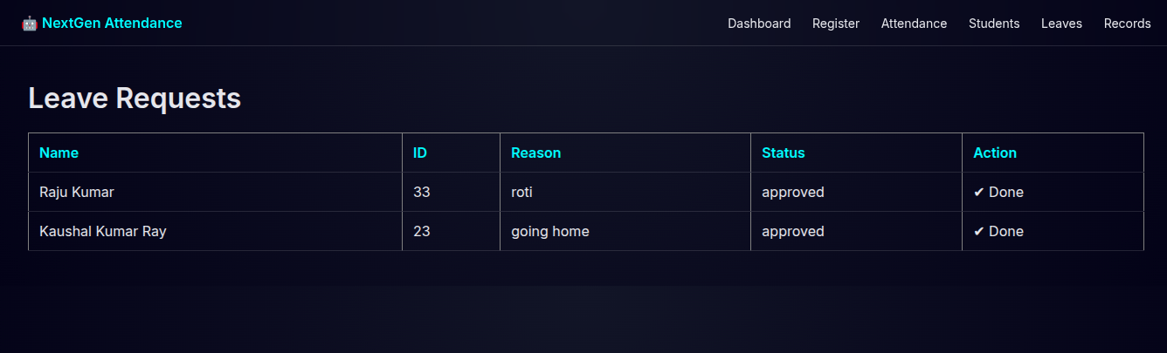

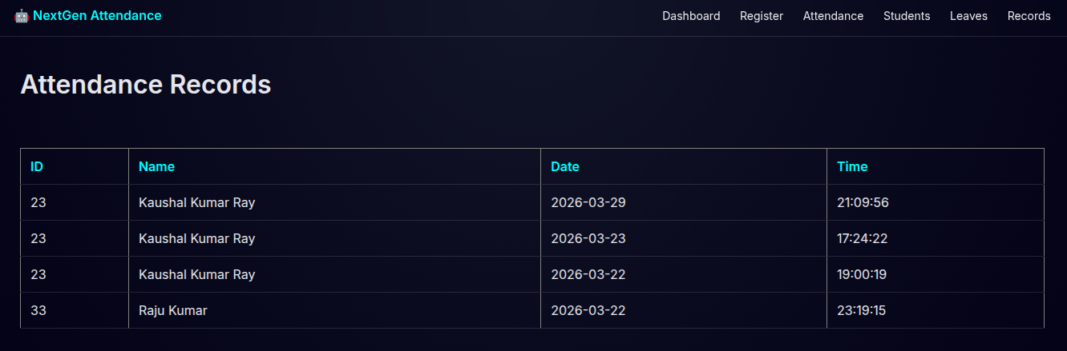

Evaluation Metrics:
- Accuracy
- Precision & Recall
- False Acceptance Rate (FAR)
- False Rejection Rate (FRR)
- Processing Time

Challenges Faced
During the development of the project, several challenges were encountered:
- Incorrect attendance logic where students were marked present even if they were absent on a specific day. This was fixed by checking attendance based on the current date instead of total records.
- Database connection issues due to DNS errors while connecting to Neon PostgreSQL. This was resolved by fixing network and environment configurations.

- Low accuracy initially due to a small dataset. This was improved by capturing multiple images and applying data augmentation.
- UI issues such as small text and poor visibility on the camera screen. This was improved by redesigning the interface and increasing text size.
- Performance issues due to repeated API calls. This was fixed by optimizing request handling.
- Face recognition errors under different lighting conditions, which were improved using better models like ArcFace.

Results
The system successfully detects and recognizes faces in real time and marks attendance automatically. It also calculates attendance percentage correctly after fixing the logic.
The use of deep learning improves accuracy compared to traditional methods. Data augmentation also helped improve recognition performance. (Reference GJETA)

Conclusion
The proposed system provides an efficient and automated solution for attendance management using face recognition. It reduces manual work, improves accuracy, and prevents proxy attendance.
The system is scalable and can be used in educational institutions and organizations. Future improvements can include mobile integration and advanced security features.

References
- Deng et al., ArcFace: Additive Angular Margin Loss for Deep Face Recognition (Reference ArcFace)
- Essien et al., Deep Learning-Based Face Recognition Attendance System. (Reference GJETA)
- Schroff et al., FaceNet: A Unified Embedding for Face Recognition



(Project link : https://github.com/Kaushal-Kumar-Ray/NextGen_Attendance)

Hardware Required:
1. System : Minimum i5 Processor
2. Hard Disk : 512 GB
3. RAM : Minimum 16 GB

Software Required:
1. O/S : Windows/Linux.
2. Language : Python, DeepFace, Flask
3. Data Base : PostgreSQL, Cloudinary
4. Frontend : HTML5, CSS, JavaScript

Project Guide Name with Sign:-

Project Co-Coordinator HOD DEAN

